 | 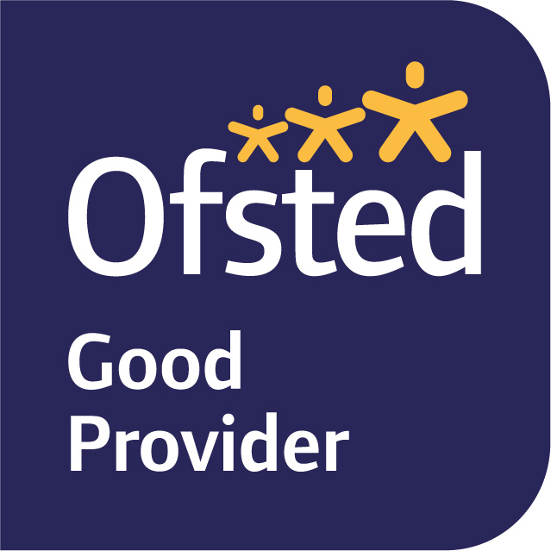

September 2026
Dear Parents/Carers,
Welcome to Cherry Class! The children are making a fantastic start to the year, exploring their new classroom and outside area.
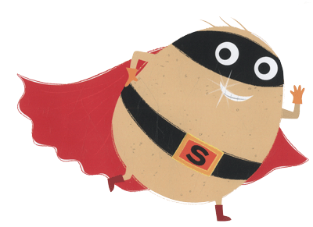
Our learning journey this term is SUPERHEROES! We will be exploring this topic with some exciting writing. We will be using the books, ‘Traction Man, ‘Supertato, and Superhero Mum’ to inspire us and aid our imaginations in our writing.
In Maths, we are going to be exploring place value with numbers to 100 and securing our knowledge of this to help us with addition and subtraction using the column method and number lines! Children will use concrete and pictorial representations to support their understanding and reasoning of numbers to 100. We will also look at 2D and 3D shapes - Children will learn to describe and sort shapes based on the shapes’ mathematical properties, using the correct terminology.
Phonics will be taught daily as a whole-class. Initially, we will be revising the sounds the children learnt towards the end of Year 1 before moving onto to learning the next sounds. Phonics is a fundamental part of the children’s learning in Year 2, so we would strongly encourage you to work on this with your children at home where possible.
Each week the children will have the opportunity to visit the school library on a Monday to change their books. We ask that both library books and decodable books are returned on a Monday. The children will have new decodable books reissued on the Monday.
In Science this term we will be exploring materials; we will be sorting, classifying and finding out what they are used for and how suitable materials are for different jobs. This will culminate in us testing various materials to choose the correct material for Traction Mans new outfit.
In Geography the children will be learning to use both locational and directional language when learning about our school and Lewes. The children will be drawing maps, giving directions and learning about North, South, East and West.
In Design Technology the children are going to learning about movable parts in books, namely sliders and levers. We will be evaluating existing books before planning, designing and making our own lever/slider to move a superhero character across a scene.
In Music the children will use their voices expressively and creatively by singing songs and speaking chants and rhymes, they will play tuned and untuned instruments musically.

In RE the children will be learning about what it means to belong to a faith community and that non-religious and religious people join together in communities to help support each other. We will be visiting

PE will be on Monday and Friday. Children will need to come to school in their PE kits on these two days. If your child has pierced ears, please make sure that they can either take their earrings out themselves or that they do not wear them on these days as we are unable to allow the children to wear any form of jewellery for PE.
The children have had a great start in Year 2 and we will continue to update Tapestry with all the learning they are taking part in so please have a look. If you have any queries, please do not hesitate to speak to one of us after school.
Kind regards,
Mrs Bishop, Mrs Wooler, Mrs Quinn and Mrs Zarrabiyeh.
Year 2 Team

