 | 

Dear Parents and Carers,
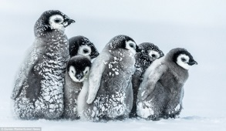
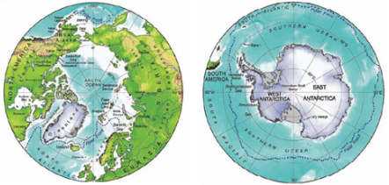
Term Two has arrived and our topic is ICE! This term we will be exploring the polar regions of the world, finding out about what these unique environments are like and how animals and plants survive there. Our enquiry question is ‘What do we know about the world and how does it shape the way we live?’
In English, we will be reading ‘Emperor’s egg’ and researching all about emperor penguins in order to write our own versions of a non-fiction text in a story style. As well as this we will also be writing Autumn poems and using the books ‘Dear Greenpeace’ and ‘Lost and Found’ to write instructions on how to look after an arctic animal.
In Maths, we will continue to focus on place value, addition and subtraction. Using column addition and subtraction to find and explain answers.
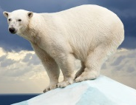
In Science, we are studying living things and their habitats, looking at how living things are adapted to their environment, such as polar bears in the Arctic. In PSHE we will be discussing responsibility and consequences linking this in with discussions about climate change. In RE the children will be thinking about Christianity and the Christmas story in preparation for the Nativity later in the term. In History we are learning about Ernest Shackleton and his polar expeditions. In music we are focussing on singing experimenting with pitch, dynamics and tempo using our voices.
We will have PE on Wednesday and Friday. Please wear PE kit to school on these days.
I am looking forward to a fun term
Kind regards,

Mrs Bishop and Mrs Bedford
Year Two Class Teachers

