Year 2 Term 4 Homework Grid
Please consider choosing 2-3 tasks a week to complete.
**Maths and Reading are suggested to be a priority.**
Maths  Target time 15mins | Reading/Writing  Target time 15mins | Topic/Creative  Target time 20mins
. **Times table rock stars. We have been learning our 2’s, 3’s 5’s and 10 times tables. Logins were sent home on the last day of term.  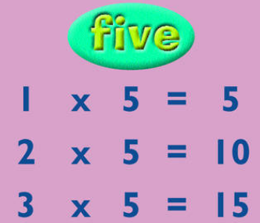 | Can you do a book review of your favourite book? Bring it in to share with the class.  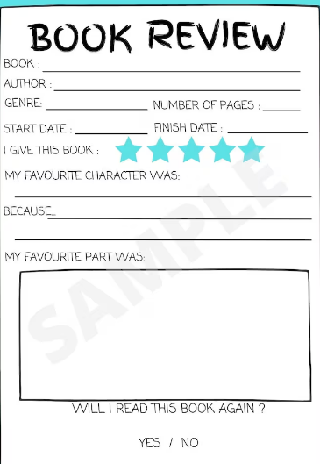 | In Geography we are learning about different landmarks in London e.g. The monument, Big Ben, Houses of parliament. Can you choose a landmark in London and write a fact sheet. You could include the answers to the following question.  When was it built?  How tall is it?  What materials have been used to build it?  What is it used for?  
**MYMaths – a series of new tasks are set for the term.  We would recommend you do 1 per week as they align with the teaching in the class e.g. start on 2A, 2B etc. | 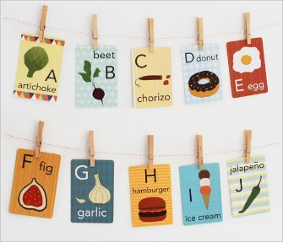  These are the spellings we are focusing on this term:  child pretty gold parents beautiful  children father  steak whole half clothes | Reflect on the image below of the Great Fire of London and using various media create your own version depicting the fire.  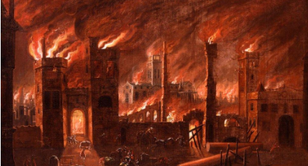
We are currently learning to join when writing. When the children write at home if you can please encourage them to write joined up. I have added a link to support them as they pratice at home. https://www.teachhandwriting.co.uk/continuous-cursive-beginners-choice-4.html Please select continuous cursive.

