Year 2 Term 2 Homework Grid
Please consider choosing 2-3 tasks a week to complete.
**Maths and Reading are suggested to be a priority.**
Maths  Target time 15mins | Reading/Writing  Target time 15mins | Topic/Creative  Target time 20mins
. **Times table rock stars. We have been learning our 2’s, 3’s 5’s and 10 times tables. Logins were sent home on the last day of term.  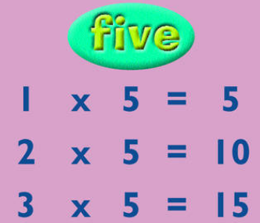 | Can you write a diary entry of what you did one weekend. Remember to write it in the first person. E.g. This morning I woke up and had my favourite breakfast. I then got dressed and we decided to take the dog for a walk to the local park.   | We will be learning all about different habitats and why animals are suited to live in each one. I would like you to choose an animal that lives in a polar habitat and create an eye catching poster telling me all about them. I have provided some questions you could answer below.  (Where do they live? What do they eat? How are they adapted to living in the arctic? What do they look like?)
**MYMaths – a series of new tasks are set for the term.  We would recommend you do 1 per week as they align with the teaching in the class e.g. start on 2A, 2B etc | Practise your spellings. They are: cold  wild  Christmas  mind  both  because  kind  move  many  again  busy | Science Experiment. Can you freeze some ice cubes and carry out an experiment to see what will melt the ice the quickest. You will need to time how long it takes for the ice to start to melt. You could try sugar, salt, warm water and something else of your choice. You need to write down your predictions before you begin. Can you explain why the ice melted slower/quicker.
Do some baking or cooking where you will need to do some measuring and reading a recipe. | **Read an information book about an animal that lives in a polar habitat.
Please ensure your child practises their words for the nativity. The script was sent out on the last day of term.

