How can I be a Superhero?
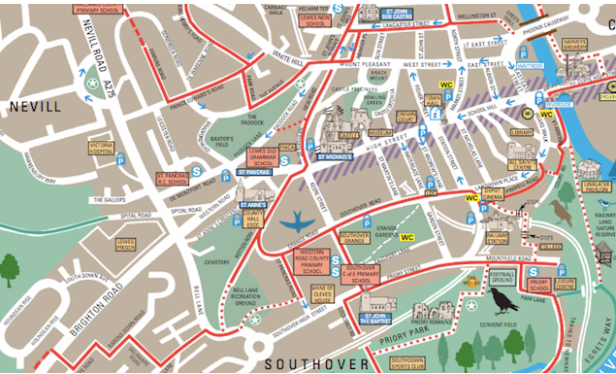


This term we will be learning about what makes us as individuals Super. We will be becoming independent learners in the classroom, showcasing our strengths and learning new skills.

We will become Scientists when learning about the properties of different materials to help make a new outfit for Traction Man. We will be creating our own comic strip in computing reflecting on the main story structure of our core book Traction Man.

We are going to learn how to think like a geographer. We will be focusing on the journeys we take to school and around school. We will be creating our own maps and following maps using directional language to describe where we have been or where we are going.

.

Overview
Language of a Scientist
Materials | A physical substance that things are made from.
Flexible | Able to bend or be bent easily without breaking.
Waterproof | A piece of clothing that does not let the water through and keeps you dry.
Strong | Difficult to break or destroy.
Language of a Geographer
Maps | A drawing of the shape and position of features of an area such as roads and buildings.
Direction | The position towards which someone or something moves or faces.
North South East West | The points of a compass showing the direction of something or someone.
Left Right  Forward Back | Used to direct something or someone.
Landmarks | A building that is easily recognised, especially to judge where you are.
Human features | Features that have been built by humans e.g. buildings, train tracks, roads, pavement.
Physical Features | Features that are natural to the world around us. For example,. hills, mountains, rivers.
Weather Patterns | The conditions in the air above the earth, such as wind, rain or temperature.

Key questions to ask yourself and activities you can do at home
-Can you draw a map of your journey to school?
-Go for a walk and count how many physical and human features you can spot.
-Talk to your parents/carers about journeys they have been on. This can include going abroad - how did they get there? How long did it take?
-When using an object, think about why was the material used to make the object? What properties of the material make it suitable?

Dates for your diary
Wednesday 21st October Superhero Day- Dress up as something you are super at? Or as your favourite superhero.
Websites
Can you find your home on street view?-https://www.google.co.uk/maps/-
All about materials -https://www.bbc.co.uk/bitesize/topics/zrssgk7/articles/z6jm7yc
https://www.bbc.co.uk/bitesize/topics/zrssgk7/articles/zvpysk7

