 | 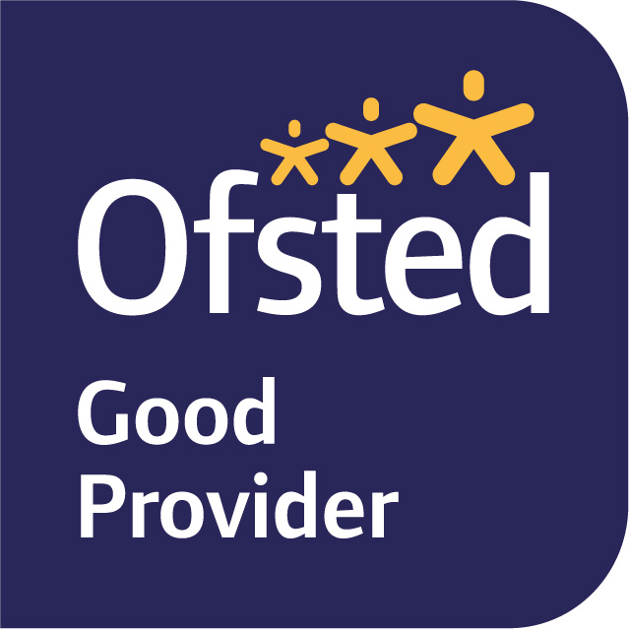

November 2025
Dear Parents/Carers,
Welcome back to term 2. We hope that you had a restful half term. Our learning journey this term is ‘Ice’ We will life in the arctic and Antarctica. Comparing life on the ice to life in the UK and Lewes.
In our English lessons we will be exploring two books. Starting with ‘The Storm Whale in Winter.’ By Benji Davies. This is a sequel to ‘The storm whale.’ Which we will also read as part of our learning. We will be learning about non-fiction books and building up to write our own non-fiction page about whales. Towards the end of the term we will also be exploring ‘The Snowman’ by Raymond Briggs.
In maths we will continue to explore addition to 10 before moving on to look at subtraction within 10. These units will continue to build upon the children’s understanding of number bonds to 10, ten frames and part-whole models.
We continue to teach phonics daily. This term we are beginning to explore the extended code which introduces children to ‘one sound spelt different ways.’ This is supported by guided reading, which we have started this term. During the week, the children will have the opportunity to read in a group with the teacher. They will also explore a picture book each week through a carousel of activities.
The children continue have the opportunity to visit the library every other Monday to choose a book to take home and enjoy. (This term it will be on the 10th, 24th, 8th and then an extra one on 19th to ensure children have a book over the holidays)
In Science this term we will be exploring animals. Each week we will learn about one classification of animals, such as mammals or amphibian. The children will be grouping and comparing animals. We will link this to our learning of ice by thinking about how animals adapt for icing places and what their habitats might look like.
In Geography we will be exploring the polar regions and comparing their climate, animals and how people live with Lewes and our local environment. We will also listen to stories of explorers and discuss the effect of climate change on the polar regions.
In Art the children will begin to explore different mark making using their own sketch books. They will be using a range of medium including ink, charcoal and paint.
In Music we are listening and appraising two different songs, focusing on rhythm and pitch. We will also be enjoying singing our Nativity songs.

In RE our question this term is ‘What do Christians believe God is like?’ In this unit we will be learning the parables of The Prodigal son and The Lost Sheep. We will be learning about the story of Jonah and the big fish and using this to think about how Christians pray and worship. To support this learning we will be visiting St John’s Sub Castro Church on 2nd December. More information to come.

PE will be on Wednesday and Friday. Children will need to come to school in full PE kits on these days. Please ensure that your child has long trousers this term, such as tracksuit bottoms, and a jumper.
We are not setting homework in Year 1 for this term, however please continue to support your child at home by listening to them read both their decodable book and other books and speaking to them about their learning in school.
Please ensure that your child comes to school each day with a waterproof coat with a hood. This allows to give the children to maximum amount of time outside each day.
Kind regards,
Mrs Bracher, Mrs Wray, Mrs Hamblin.
Year 1 Team

