Year 2 Term 1 Homework Grid
Please consider choosing 2-3 tasks a week to complete.
**Maths and Reading are suggested to be a priority.**
Maths  Target time 15mins | Reading/Writing  Target time 15mins | Topic/Creative  Target time 20mins
We are currently focusing on both numbers to 100 and shapes in our Maths lessons.  Shapes are everywhere in our environment. Can you find both 2D and 3D shapes on your walk to school and consider why the object is that shape? Could it be another shape? | Please read with your child regularly.  The children will be visiting the library and also having their reading books changed weekly.  We are currently focusing on Traction Man and will be writing our own mini Traction Man story at the end of the English unit. Can you write a story about a superhero of your choice? Remember to include both adjectives and nouns in your sentences. | In Geography we are going to be focusing on journeys we take to school and around school.  Can you draw a simple map of your route to school and place features on the map?  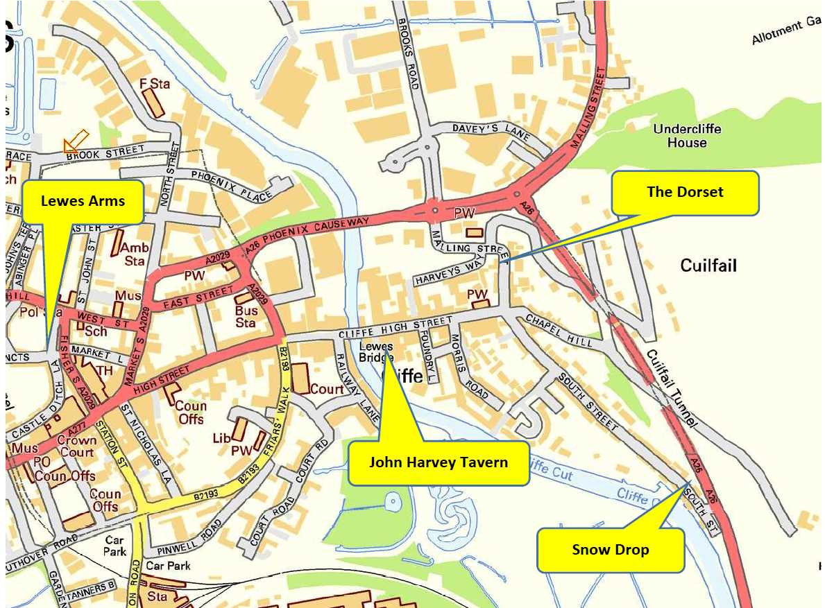
**MYMaths – a series of new tasks are set for the term.  We would recommend you do 1 per week as they align with the teaching in the class e.g. start on 2A, 2B etc. | The spellings for the term are in your child’s spelling book. Please practice these at home.  We will be carrying out a low stake quiz each Monday. The children will bring their spellings home to show you how well they have done.   | Science  We are exploring different materials and find out about properties of different materials.  Can you look closely at your favourite toy and discuss what the toy is made from. Why has the manufacturer chosen this material to make the toy? Is the toy made from one or more material? What are the properties of the materials that make it suitable?
This term in handwriting the children will being learning how to write words with lead ins and lead outs and begin to write some words in cursive. Below is a link to support them as they pratice at home. https://www.teachhandwriting.co.uk/continuous-cursive-beginners-choice-4.html Please select continuous cursive.

