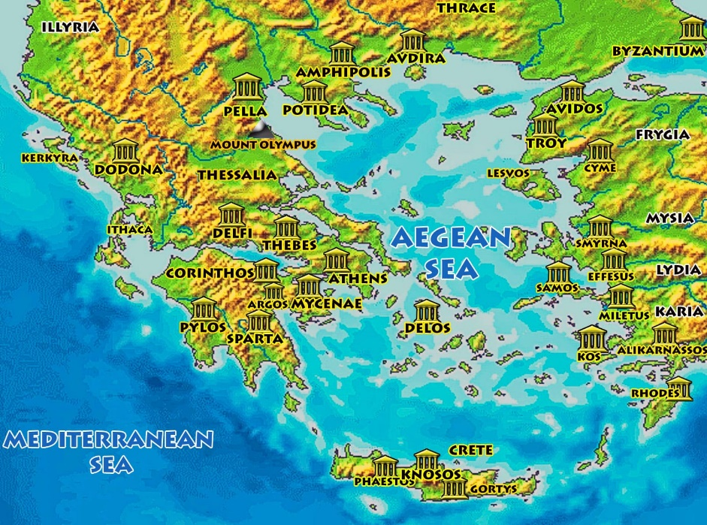
How did the Ancient Greeks change the world?
“Man: a being in search of meaning.” - Plato

Language of a historian
Legacy | The long-lasting impact of particular events or actions that took place in the past, or of a person’s life.
Primary source | Raw materials of history – original documents and objects that were created at the time of the period. These include statues, letters, diaries, coins, and clothes.
Secondary source | A document or recording that discusses a primary source. These include textbooks, dictionaries, essays, and journal articles.
Archaeology | The study of human history and prehistory through the excavation of sites and the analysis of artefacts and remains.
Civilisation | A large group of people who share certain advanced ways of living and working.
Hellenes | The name the Ancient Greeks called themselves – they were named as the Greeks by the Romans much later in history.
Polytheism | The belief in or worship of more than one god.
Hippocratic Oath | An oath of ethics taken by doctors and physicians at the start of their careers.
Democracy | A system of government in which citizens have the power to participate in political decision-making.
Ekklesia | An assembly of citizens gathered together to make political decisions.
Boule | A council appointed in each city in Ancient Greece to run its daily affairs.
Olympic Games | A sports festival held every four years in Olympia in order to honour Zeus
Language of a geographer
City state | A city that with its surrounding territory forms an independent state.
Polis | The Greek name for a city-state.
Mediterranean Sea | The sea which surrounded Ancient Greece.
Athens | A city that was the centre for the arts, learning, and philosophy in Ancient Greece
Topography | The arrangement of the physical features of an area.
Climate | The general weather in an area over a long period of time.
Olympia | The centre of worship for Zeus, the father of
Even though they lived over 2,500 years ago, the Ancient Greeks are one of the most important civilisations in human history. Many of their contributions to sports, medicine, democracy, engineering, science, and culture are still relevant today. Unlike other ancient civilisations, Ancient Greece was a collection of different city states scattered around the Mediterranean Sea which traded with and influenced each other. Throughout this term, we will discover just how much of an impact this clever civilisation has had on the modern world!
Overview

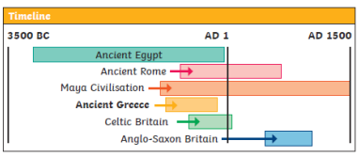

- Who were the Ancient Greeks and how do we know so much about them?
- How does Ancient Greek life compare to modern times?
- How does the legacy of the Ancient Greeks impact our daily lives?
Key questions to ask yourself

750BC
Homer, a famous poet, writes The Illiad and The Odyssey
146BC
The Greek Empire ends
c.287 BC
Archimedes, a famous inventor, was born
c.400 BC
The Hippocratic Oath is written
508 BC
Democracy is created in Athens
776BC
The first Olympic Games are held in Olympia

