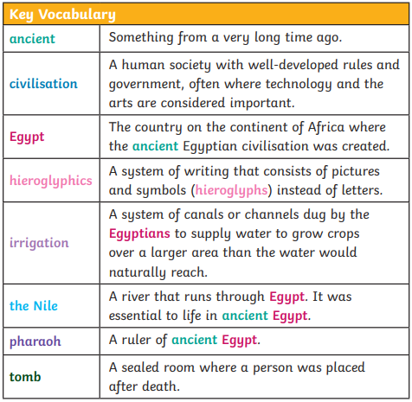
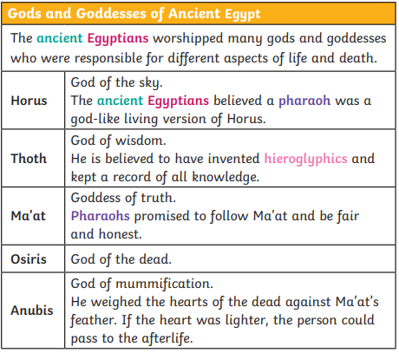
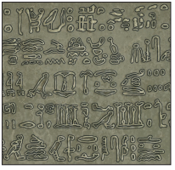
What do artefacts tell us about ancient Egypt?
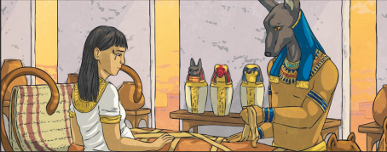
Activities to try at home
- Visit the library to take out books on ancient Egypt.
- Build a pyramid out of materials found around the house.
- Go on a virtual museum trip.
- Make a death mask.

The Nile
- Life revolved around the Nile. Every year, it flooded and left behind a black silt that enriched the soil for growing crops. The river was also used to irrigate fields in other areas.
- The Nile was used for water, fishing and trade. Mud from the river banks was used to make bricks and papyrus plants were used to make paper.
- Most people lived along and around the Nile. This is still true in Egypt today.

Key questions to ask yourself
- What does ancient mean?
- Where is Egypt?
- What is an artefact?
- What was live like in ancient Egypt?
- What did ancient Egyptians believe in?
- Who are important ancient Egyptians?
- What resources can I use to find out more information?

Historical Key Vocabulary
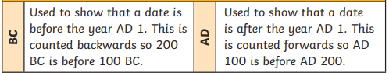

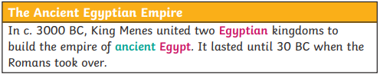
Rosetta Stone
Did You Know…?
The Rosetta Stone was discovered in 1799. It was written in hieroglyphs and two other languages, including ancient Greek, which language experts could still read. They translated the hieroglyphs by comparing the languages. It took 20 years to translate all
the text into modern language.

Tutankhamun
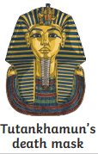
- Tutankhamun was a pharaoh known more recently as the ‘boy king’ because he became pharaoh when he was 9 years old.
- His tomb was discovered by Howard Carter and his team in the Valley of the Kings in 1922.
- The discovery helped people to understand more about the Egyptians pharaohs.

